**Week 8 Mandatory Hands-on :**

1. **A screenshot of a computer program

   AI-generated content may be incorrect.Git-HOL** A computer screen with white text

   AI-generated content may be incorrect.

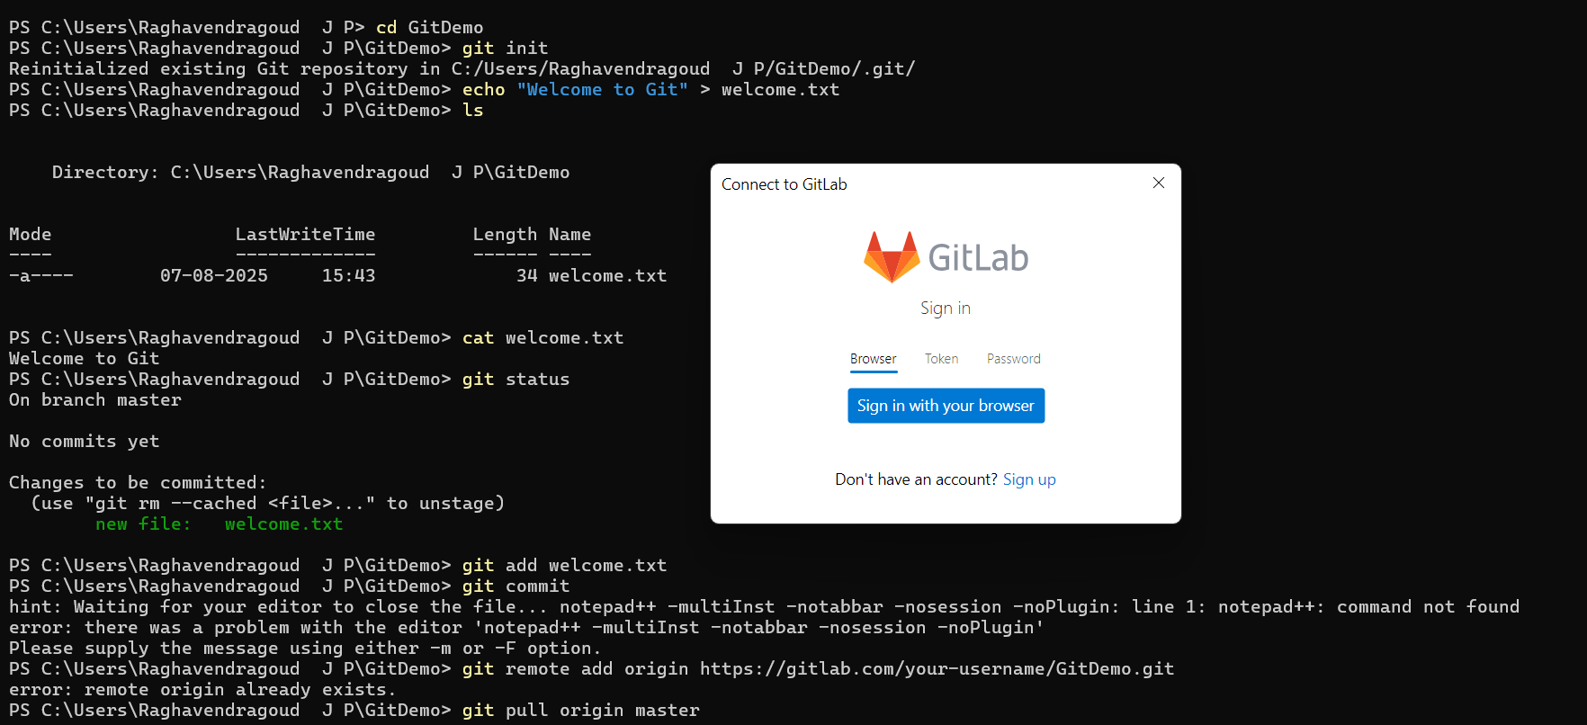

1. **Git-HOL**

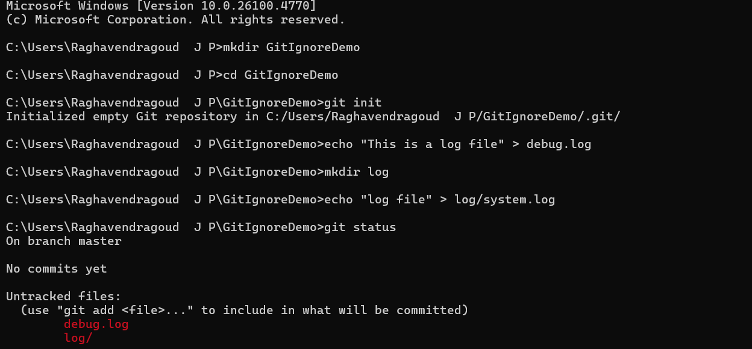

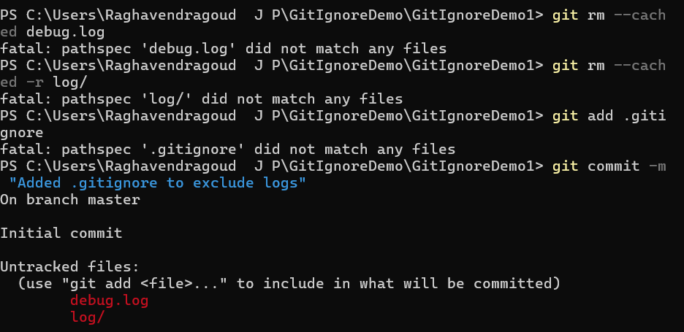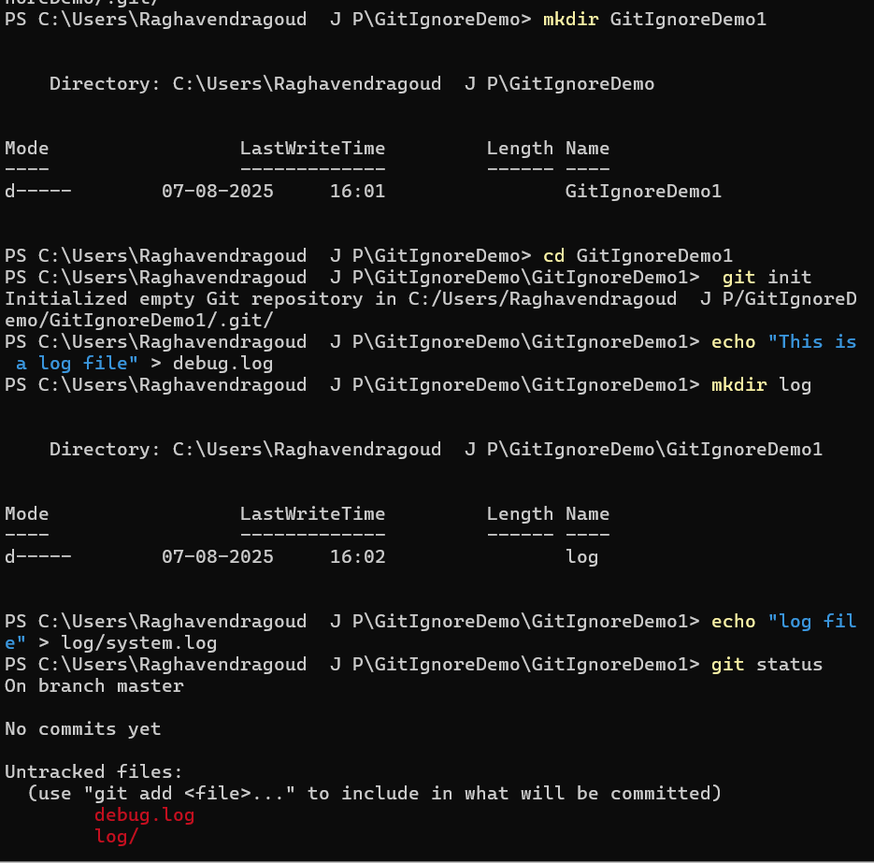

3. Git-HOL

**3. Git-HOL**

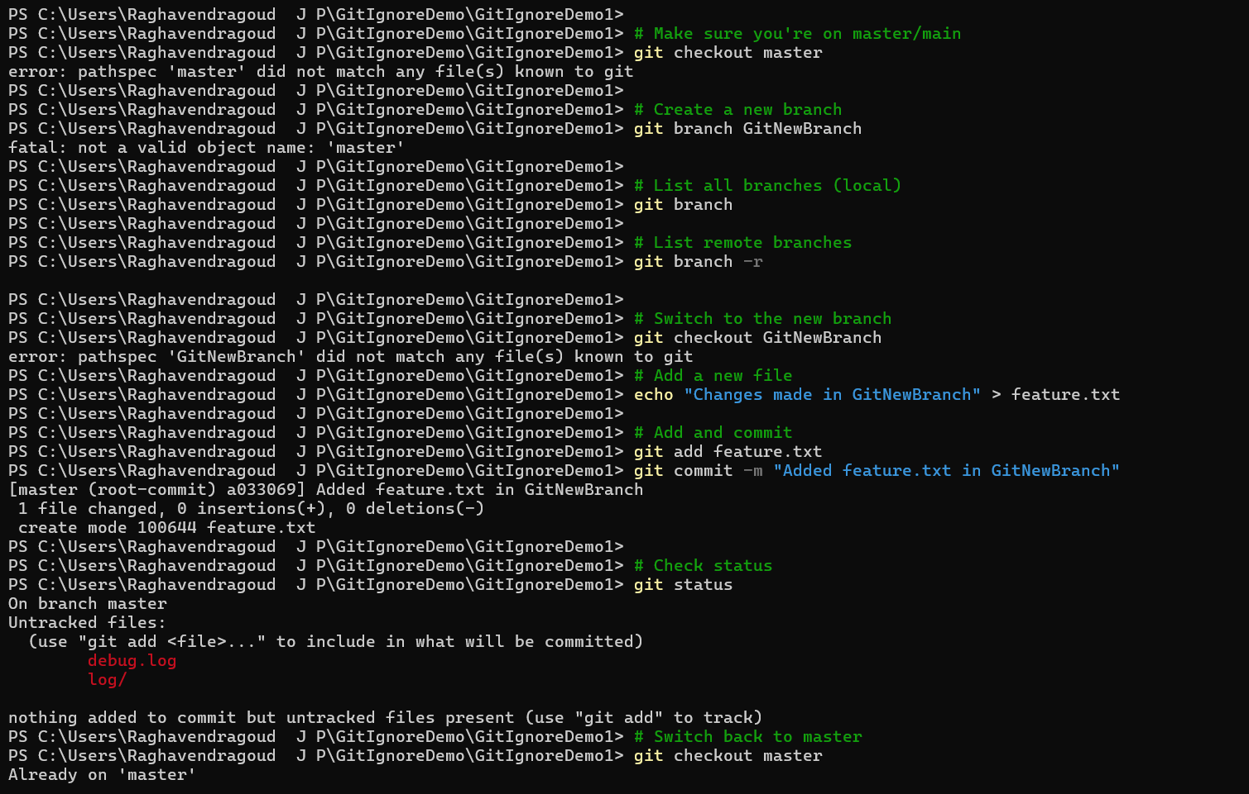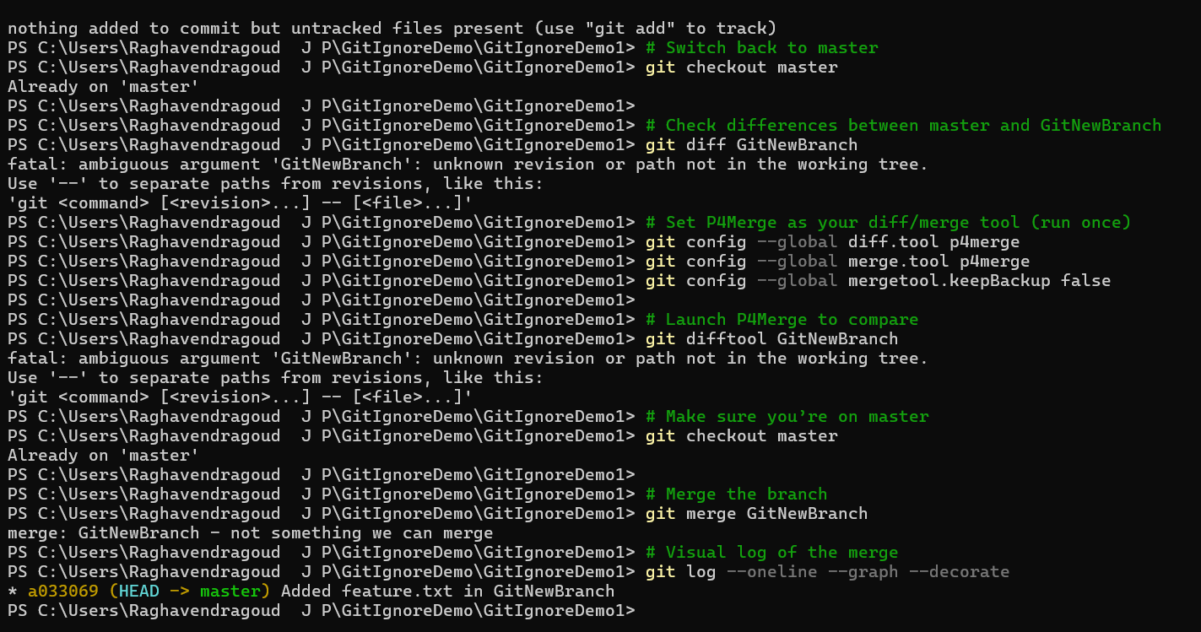

**4. Git-HOL**

